SHUBHAM GARG

BATCH : F2

ENROLL. NO.: 9919BT-CSE115

WEEK 2 LAB B

<html>

<head>

<title>The PUNK</title>

</head>

<body background="abc.jpg">

<center>

<img src="punklogo.jpg" width="150px" height="60px" align="left"><br>

<hr>

<pre><font size="6"><a href="thepunkwebsite.html">Home</a> | <a href="thepunkwebsite.html">About Us</a> | <a href="gallery.html">Gallery</a> | <a href="achieve.html">Achievements</a> | <a href="loginweb.html">Login</a> | <a href="contact.html">Contact Us</a></font></pre>

<hr>

</center>

<marquee><font size="6" color="paleblue">Welcome to THE PUNK</font></marquee><br><br>

<img src="buddha.jpg" align="right" height="500" width="400">

<h1><FONT size="8" color="white"><b>Welcome To THE PUNK SCHOOL</h1>

<font size="5" color="WHITE">THE PUNK is a Music and Dance educational school. It is related to the efficient

and co-operative staffcheerful and cozy ambiance, pleasing interiors, appreciable surroundings endowed with

modern & latest instrumentation and all the necessary facilities to render Indian and Western Music and Dance

education to our fellow students in the best way.<br>

We aim at providing the knowledge of subject with friendly behavior, affectionate attitude and generous efforts

to benefit our fellow students to the fullest.<br>

The children are hosted with special care for their harmonious development in all the fields as it is the best period

to build in them a good attitude towards life.<br>

The youngsters are guided to let them put their energies in the appropriate directions.<br>

The elderly groups in The Punk are fortunate to have rejuvenating benefits for their minds and souls

in today's hectic and harsh business lives.<br>

The Punk's team feels grateful in owing its students' responsibilities.<br>

</font>

<img src="pic1.jpg" width="200px" height="200px">

<img src="pic2.jpg" width="200px" height="200px">

<img src="pic3.jpg" width="200px" height="200px">

<img src="pic4.jpg" width="200px" height="200px">

<img src="pic5.jpg" width="200px" height="200px">

<img src="pic6.jpg" width="200px" height="200px">

<img src="pic7.jpg" width="200px" height="200px">

<img src="pic8.jpg" width="200px" height="200px">

<img src="pic9.jpg" width="200px" height="200px">

<img src="pic10.jpg" width="200px" height="200px">

</body>

</html>

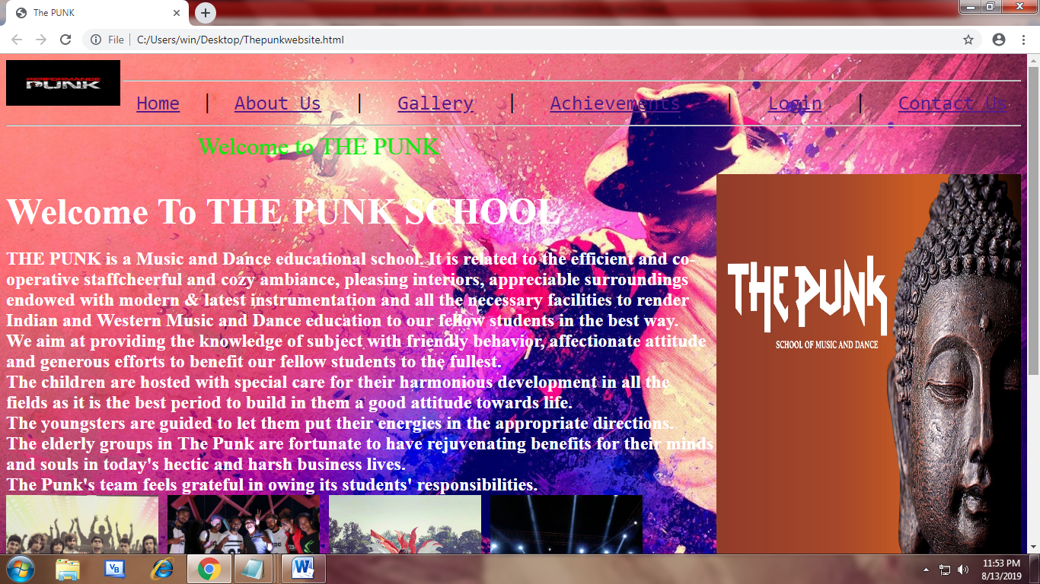

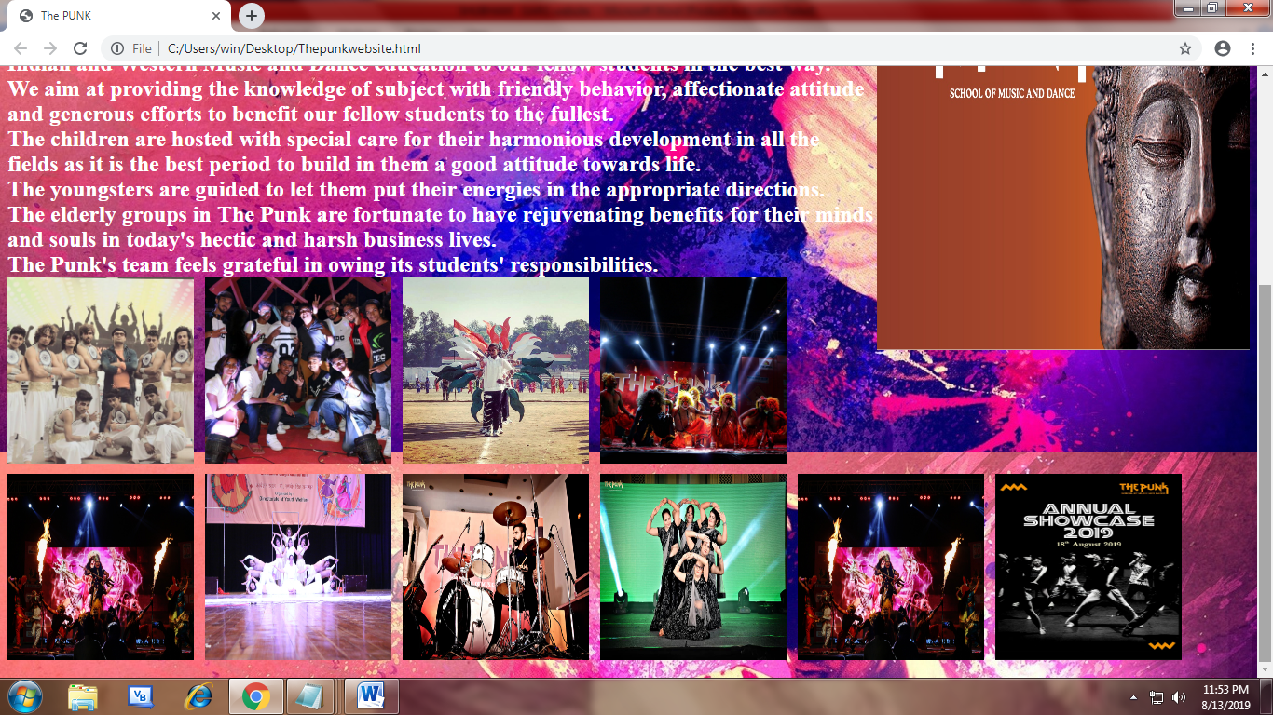

<html>

<head>

<title>The PUNK</title>

</head>

<body background="gallery.jpg">

<center>

<img src="punklogo.jpg" width="150px" height="60px" align="left"><br>

<hr>

<pre><font size="6"><a href="thepunkwebsite.html">Home</a> | <a href="thepunkwebsite.html">About Us</a> | <a href="gallery.html">Gallery</a> | <a href="achieve.html">Achievements</a> | <a href="loginweb.html">Login</a> | <a href="contact.html">Contact Us</a></font></pre>

<hr>

</center>

<marquee><font size="6" color="paleblue">Welcome to THE PUNK</font></marquee>

<img src="pic1.jpg" width="300px" height="300px">

<img src="pic2.jpg" width="300px" height="300px">

<img src="pic3.jpg" width="300px" height="300px">

<img src="pic4.jpg" width="300px" height="300px">

<img src="pic5.jpg" width="300px" height="300px">

<img src="pic6.jpg" width="300px" height="300px">

<img src="pic7.jpg" width="300px" height="300px">

<img src="pic8.jpg" width="300px" height="300px">

<img src="pic9.jpg" width="300px" height="300px">

<img src="pic10.jpg" width="300px" height="300px">

</body>

</html>

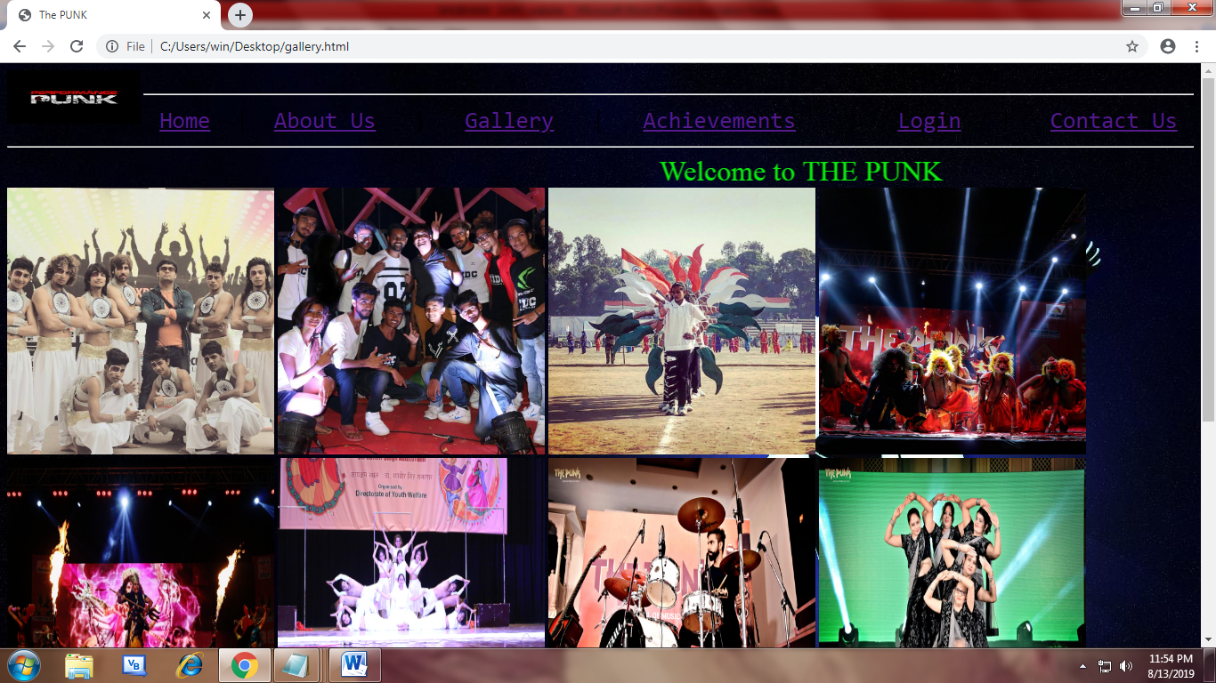

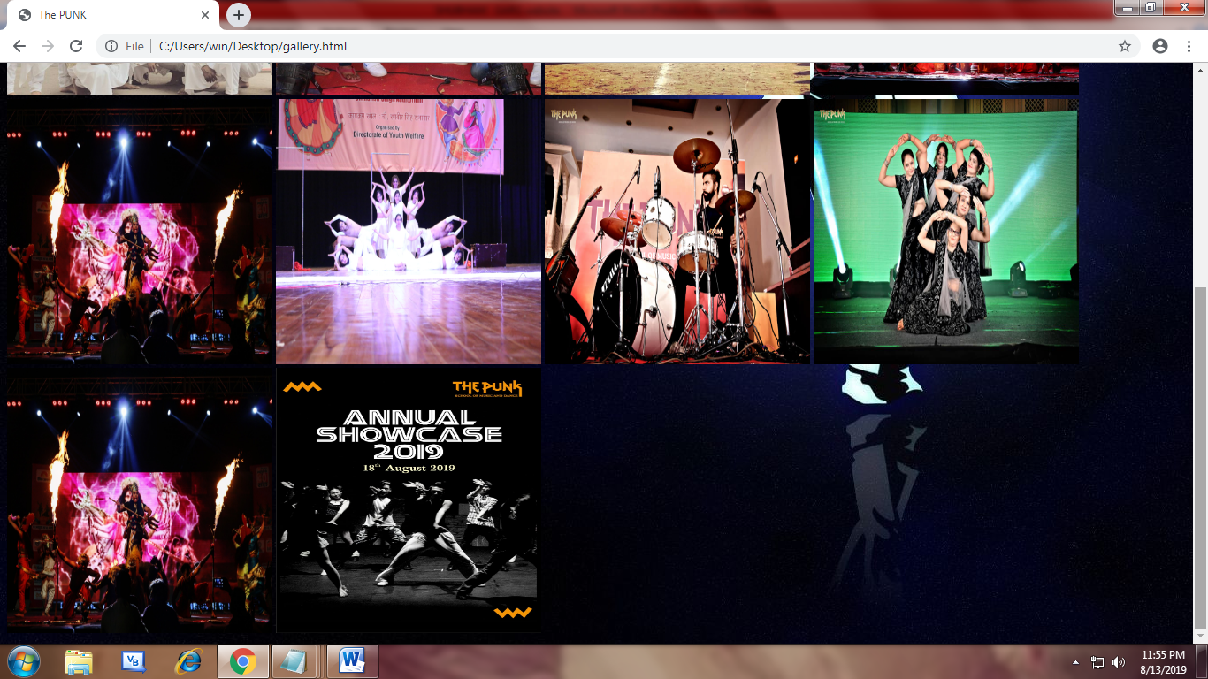

<html>

<head>

<title>The PUNK</title>

</head>

<body background="trophies.jpg">

<center>

<img src="punklogo.jpg" width="150px" height="60px" align="left"><br>

<hr>

<pre><font size="6"><a href="thepunkwebsite.html">Home</a> | <a href="thepunkwebsite.html">About Us</a> | <a href="gallery.html">Gallery</a> | <a href="achieve.html">Achievements</a> | <a href="loginweb.html">Login</a> | <a href="contact.html">Contact Us</a></font></pre>

<hr>

</center>

<marquee><font size="6" color="paleblue">Welcome to THE PUNK</font></marquee>

<center><H1>THE PUNK LAURELS</h1></center>

<ul>

<li><font size="5"><b>First Prize in State Level Dance War Held at Chandigarh by the Senior Dance Group</li>

<li>Trophy of the Best Dance Group of Haryana in HPL (Haryana Premier League).</li>

<li>Selection of Mohit Sharma in Top 16 Sa Re Ga Ma Zee TV Haryana Icon.</li>

<li>Selection of 16 Students in Chak Dhoom Dhoom team challenge till studio round and

appreciated by Javed Jaffery and Malika Sherawat.</li>

<li>The Punk got the trophy of best dance group of Haryana by"Terence Lewis"</li>

<li>8 gold medals and two silver medals in INTERNATIONAL LATIN DANCE CHAMPIONSHIP.</li>

<li>First prize among 20 best teams and Awarded as Best Dance team of National chitkara festival 16 and

honoured with cash prize worth 1 lacs.</li>

<li>First prize in state dance competition Dance MAHA SANGRAM in Kurukshetra honoured and

awarded with cash prizes by shreyas fame MJ5.</li>

<li>Third prize in state Dance battle in Ludhiana. Awarded and honoured by DHARMESH SIR fame DANCE INDIA DANCE</li>

<li>4 students selected in India's first online Dance championship 'Jam ke Naach'

by PRINCE GUPTA fame DANCE INDIA DANCE.</li>

<li>2nd position in NORTH INDIA BATTLE OF BANDS by Big fm 94.5 SHIMLA.</li>

<li>4 students selected in grand finale of JUST DANCE INDIA by vegeta and group.</li>

<li>Our student gungun selected for TV SHOW BHOOTU on zee tv.</li>

<li>Our dance team was honoured by DANGAL GIRL BABITA PHOGAT at midtown grand, Hisar</li>

</ul>

</body>

</html>

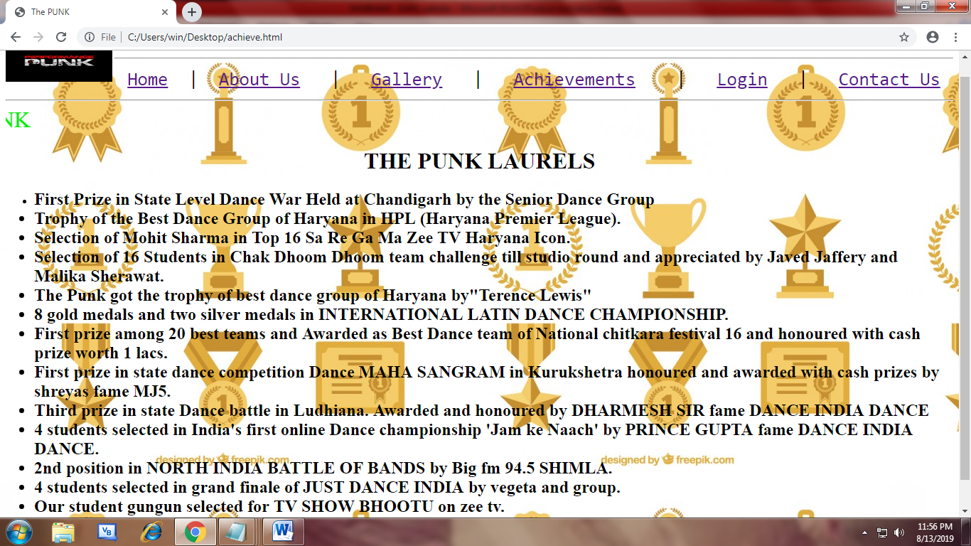



<html>

<head>

<title>Registration</title>

</head>

<body align="center" background="logindance.jpg" >

<center>

<img src="punklogo.jpg" width="150px" height="60px" align="left"><br>

<hr>

<pre><font size="6"><a href="thepunkwebsite.html">Home</a> | <a href="thepunkwebsite.html">About Us</a> | <a href="gallery.html">Gallery</a> | <a href="achieve.html">Achievements</a> | <a href="loginweb.html">Login</a> | <a href="contact.html">Contact Us</a></font></pre>

<hr>

</center>

<marquee><font size="6" color="paleblue">Welcome to THE PUNK</font></marquee>

<h1>Registration</h1>

<font size="6" color="azure">Username:</font><input type="text" name="uname" maxlength="50" value="Username"><br>

<font size="6" color="azure">Password :</font><input type="password"name="password"><br>

<input type="submit" value="Login">

<input type="reset" value="Reset">

<a href="signupdance.html">Signup</a>

<p valign="bottom">Copyright 2019 &copy All Rights Reserved</p>

</body>

</html>

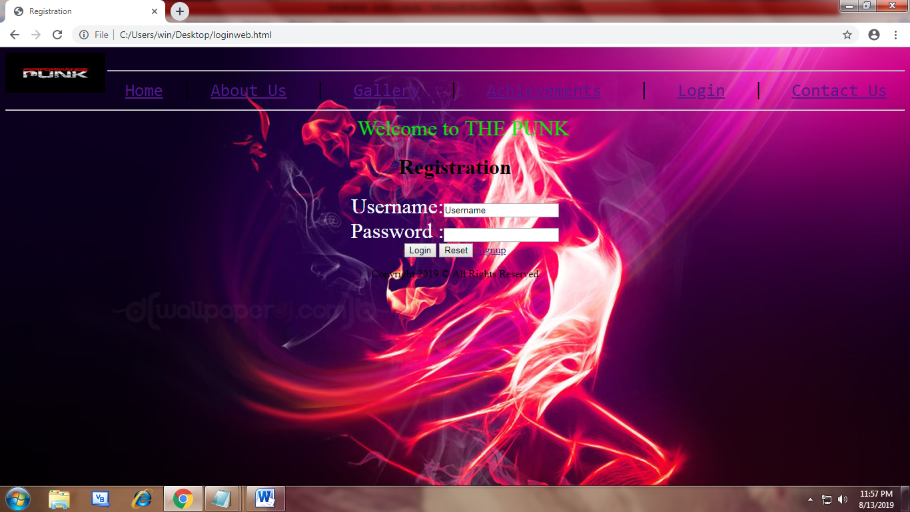

<html>

<head>

<title>The Punk</title>

</head>

<body background="signupimage.jpg" align="center">

<img src="punklogo.jpg" width="150px" height="60px" align="left"><br>

<hr>

<font size="10" color="grey">

<b><i>The Punk</i></b>

</font>

<hr>

<h1>New User</h1>

<form>

<font size="5"><label>Firstname:<input type="text" name="fname" value="Firstname"></label><br>

<font size="5"><label>Lastname:<input type="" name="" value="Lastname"></label><br>

<font size="5"><label>Gender:<input type="radio">Male<input type="radio">Female</label><br>

<font size="5"><label>Contact No.:<input type="text" name="contactno" value="9999999999"></label><br>

<font size="5"><label>E-mail:<input type="text" name="email" ></label><br>

<font size="5"><label>Date of Birth:<input type="date" id="send" oninput="result.value=send.value">

<input type="text" id="result">

<br><br>

<label>Comments:<textarea cols="30" rows="4"></textarea></label><br>

<input type="submit" value="SUBMIT"><input type="Reset" VALUE="RESET"><br>

<a href="logindance.html">Back To Home</a>

</form>

</body>

</html>

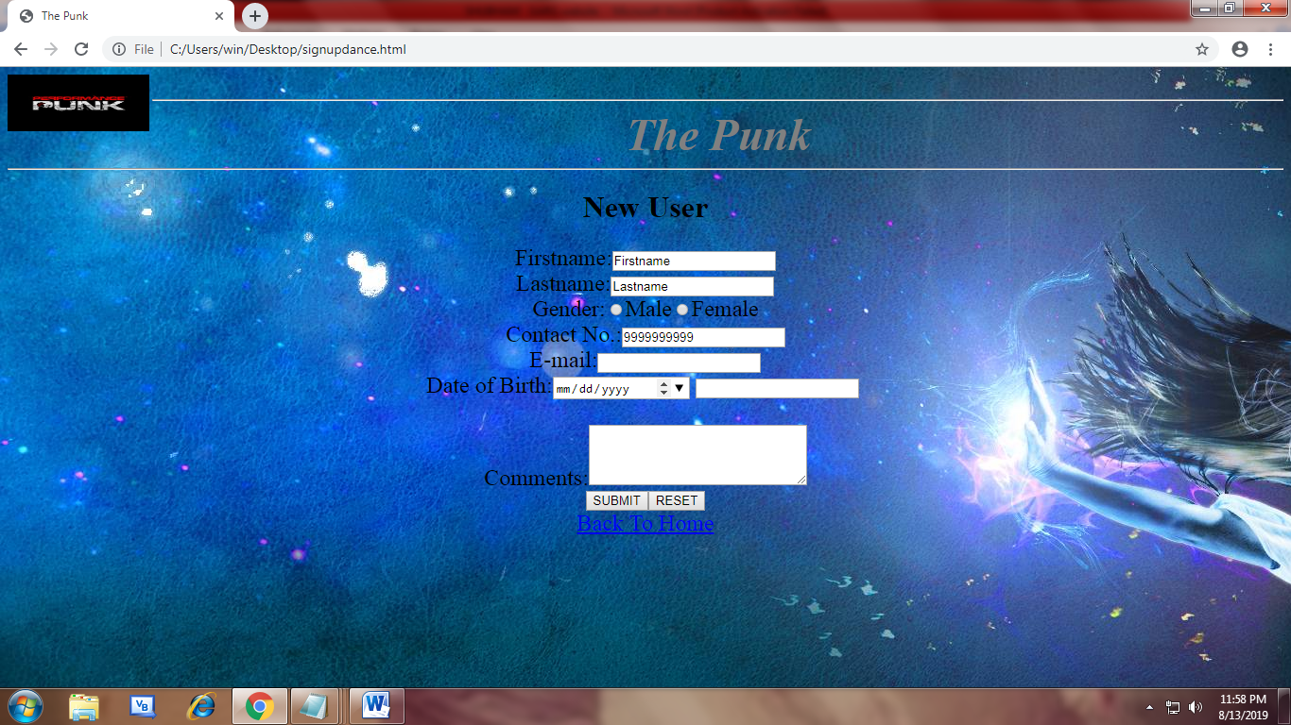

<html>

<head>

<title>The PUNK</title>

</head>

<body background="dancewhite.jpg">

<center>

<img src="punklogo.jpg" width="150px" height="60px" align="left"><br>

<hr>

<pre><font size="6"><a href="thepunkwebsite.html">Home</a> | <a href="thepunkwebsite.html">About Us</a> | <a href="gallery.html">Gallery</a> | <a href="achieve.html">Achievements</a> | <a href="loginweb.html">Login</a> | <a href="contact.html">Contact Us</a></font></pre>

<hr>

</center>

<marquee><font size="6" color="paleblue">Welcome to THE PUNK</font></marquee>

<font size="8" align="center">CONTACT US</FONT><br>

<img src="contac.jpg" height="300px" width=600px" align="right">

<font size="6">E-Mail:thepunk@gmail.com<br>

9999999999,8888888888,9825354368<br>

</font>

HISAR BRANCHES<br>

<ul>

<li> S.C.F- 94, 2nd Floor, Commercial Urban Estate- II</li>

<li>204I-A, IInd Floor, Red Square </li>

<li>SCO- 104, IInd Floor, Pocket- A, Sector- 14</li>

<li>DSS- 48, Ist Floor, Sector-15</li>

</ul>

<ul>

<li> MA Dance Studio, SCO-04, Peer Muchalla</li>

<li>MA Dance Studio, SCF-264, Sector-16</li>

</ul>

</body>

</html>

